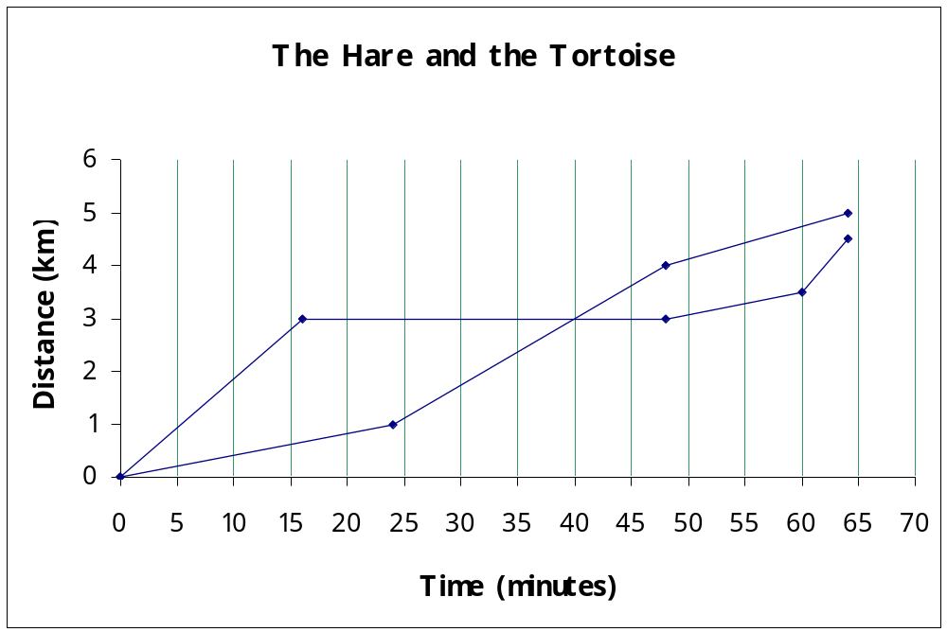

Which line represents the hare? Which line represents the tortoise?

Describe the race in detail.
Harold Hare starts quickly but, at the top of a hill, falls asleep under a tree.
Tommy Tortoise spots the sleeping hare ahead, and puts on a burst of acceleration.
Tommy silently plods past Harold and wanders off down the hill towards the finish line
Harold wakes up and sees he is behind. Unfortunately, he has slept awkwardly, has pins and needles in his left foot, and is slowed as a result
Tommy is getting puffed out, and his startling rate slows down a bit.
The pins and needles wears off, and Harold charges towards the chequered flag. But Tommy just finishes the 5km course before he is caught.

